BASIC BEEKEEPING
Presented by : Master Gardeners of Clark County (MGV CE Credits = 7hrs)
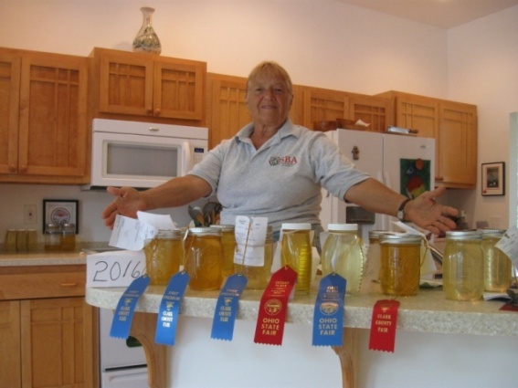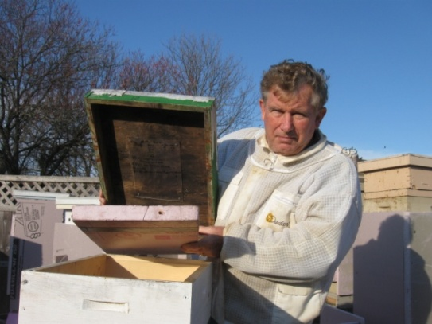
Fran Davidson with award winning honey Tom Davidson demonstrating hive insulation
Join Fran and Tom Davidson for a 7 hour course about the amazing hobby/ business of beekeeping. The multi media course is a fascinating exploration of honeybee biology and the challenging relationship between the honeybee and the modern beekeeper. The course is designed for beginning beekeepers to successfully install and raise bees the first year and beyond. Tom and Fran are certified Master Gardeners and UFIFAS certified Advanced Beekeepers. They maintain 50 bee colonies in Clark county and have operated ‘Golden Queen Honey” as a successful local beekeeping operation for 13 years.
Class offered Friday evening Jan 14 & Sat Jan 15 2022
Classroom size and Health precautions Will follow Federal, State and Local Guidlines in effect on classroom dates. Registration Checks will be returned if class clapacity reached.
Bring or locally buy your own Lunch Saturday ( 1 hour break outside classroom)
Where: Ohio State University Extension, Clark County Office
3130 East Main Street , Springfield, OH 45505
Cost : $40 per person with textbook: “Bee-Sentials” by Connor & Muir.
$25 W/O textbook (includes comprehensive notebook)
Register by January 11: Complete application & return with check to :
MASTER GARDENERS OF CLARK COUNTY, P.O. Box 158, Springfield, OH 45501 Attn Beekeeping (Check payable to Master Gardeners of Clark County)
Course Friday 14 January 2022 6:30-8:30PM & Saturday 15 Jan 2022 9AM-3PM
Name:____________________________________________________$_______
Name:____________________________________________________$_______
Address___________________________________________________________
EMail____________________________@_____________Phone_____________
Questions (Tom) 937 271 4023 or (Fran) 937 609 0956 web: steady72@aol.com

